Schrijfactie:
Kirgizië, vervolg journalisten niet

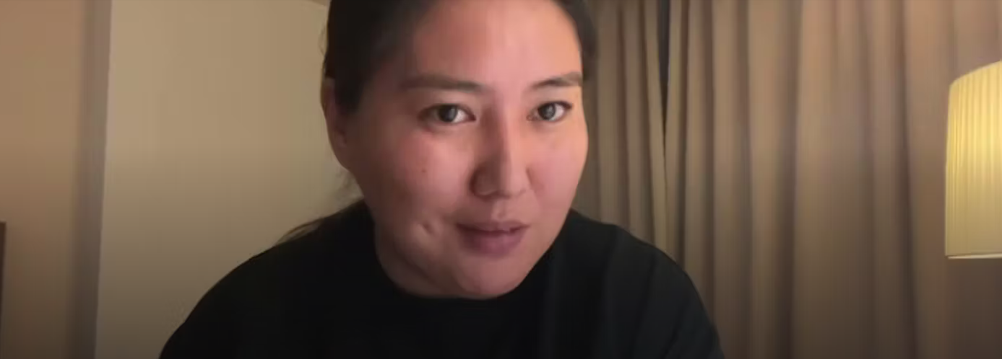

In januari deed de politie een inval in de huizen van elf journalisten die betrokken zijn bij onderzoek naar corruptie in Kirgizië. Onder hen zijn de prominente journalist Makhabat Tazhibek-kyzy (foto) en Aike Beishekeeva, een 23-jarige factchecker. Ze zouden met de publicatie van een online video oproepen tot ongehoorzaamheid, massarellen en geweld. De journalisten riskeren tot 10 jaar gevangenisstraf enkel en alleen vanwege hun kritiek op de overheid.

Wat kun jij doen?

Schrijf vóór 1 juli 2024 naar de president van Kirgizië. Roep hem op de ongegronde aanklacht tegen de elf journalisten onmiddellijk in te trekken.

Onterecht vervolgd en mishandeld
Er zijn zorgen om de veiligheid van Makhabat. Ze is in haar cel door bewakers geslagen. Ze had blauwe plekken in het gezicht en op haar bovenlichaam. Makhabat, Aike en twee andere journalisten zitten nog steeds vast. In april werden zes van de journalisten onder huisarrest geplaatst en één werd onder toezicht vrijgelaten. Maar de verzonnen aanklacht tegen hen werd niet ingetrokken.

Schrijfactie:
Thailand, laat Anchan Preelert vrij

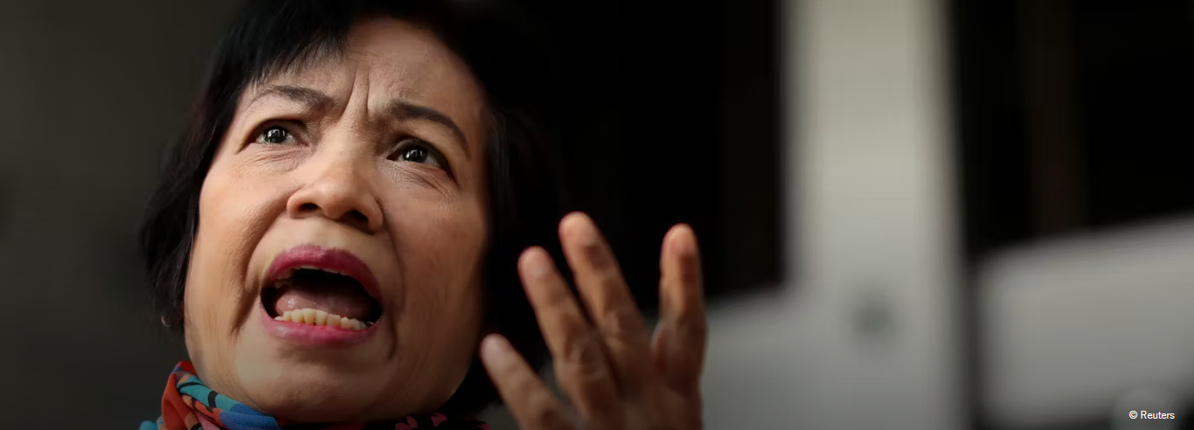

De 68-jarige voormalig ambtenaar Anchan Preelert zou van haar pensioen moeten genieten. In plaats daarvan loopt ze het risico de rest van haar leven in de gevangenis door te brengen. Haar misdrijf? Ze deelde het politieke commentaar van iemand anders op YouTube en Facebook. Ze kreeg hiervoor een absurd hoge gevangenisstraf, die afloopt wanneer ze 107 zou zijn.

Wat kun jij voor Anchan Preelert doen?
Schrijf vóór 1 juli 2024 naar de minister-president van Thailand. Roep hem op om Anchan Preelert onmiddellijk vrij te laten. Ze heeft niets misdaan.
Recordstraf voor majesteitsschennis
Militairen vielen in 2015 Anchans huis binnen en arresteerden haar. Zes jaar later kreeg ze een recordstraf van 87 jaar gevangenis voor het online delen van audiofragmenten waarmee ze de monarchie zou beledigen. Later werd haar straf teruggebracht naar 43 en een half jaar.

Sadyr Japarov, President of Kyrgyzstan
Presidential Administration of the Kyrgyz Republic
207 Abdumomunov Street
720003, Bishkek
Kyrgyz Republic

Veldhoven, May 2024

Dear Mr President,

I am writing to express my concern about the arbitrary detention and criminal prosecution of Makhabat Tazhibek-kyzy, Aike Beishekeeva, and nine other journalists and media workers associated with “Ayt Ayt Dese” and Temirov LIVE projects. I believe that criminal charges have been brought against them solely to punish them for their criticism of the authorities.

I am also deeply concerned about allegations that Makhabat was tortured or otherwise ill-treated in pre-trial detention on 5 April 2024. The Office of the Ombudsman for Human Rights in Kyrgyzstan has confirmed these allegations.

I urge you to immediately release the eleven journalists, drop all charges against them and enable them to continue their professional activities freely and without fear. Pending their release, I call on you to ensure they are protected from torture and other ill-treatment in detention.

Thank you for your attention to this urgent matter.

Yours sincerely,
Embassy of the Kyrgyz Republic
H.E. Mr. Aidit Erkin
Rue de l'Abbaye 47
1050 Brussels,
Belgium

E-mail: kgembassy.be@mfa.gov.kg

This is a copy of the letter sent to: Sadyr Japarov, President of Kyrgyzstan

Veldhoven, May 2024

Dear Mr President,

I am writing to express my concern about the arbitrary detention and criminal prosecution of Makhabat Tazhibek-kyzy, Aike Beishekeeva, and nine other journalists and media workers associated with “Ayt Ayt Dese” and Temirov LIVE projects. I believe that criminal charges have been brought against them solely to punish them for their criticism of the authorities.

I am also deeply concerned about allegations that Makhabat was tortured or otherwise ill-treated in pre-trial detention on 5 April 2024. The Office of the Ombudsman for Human Rights in Kyrgyzstan has confirmed these allegations.

I urge you to immediately release the eleven journalists, drop all charges against them and enable them to continue their professional activities freely and without fear. Pending their release, I call on you to ensure they are protected from torture and other ill-treatment in detention.

Thank you for your attention to this urgent matter.

Yours sincerely,

Prime Minister Srettha Thavisin
The Secretariat of The Prime Minister
1 Phitsanulok Road, Dusit,
Bangkok 10300 +66 2 288 4000
Thailand

E-mail: spokesman@nia.go.th

Veldhoven, May 2024

Dear Minister,

I wish to express my concern about the continued arbitrary detention of 68-years-old civil servant, Anchan Preelert. She was arrested in 2015 for posting another person’s political commentary online. Preelert is currently serving a harsh sentence of 43 years and six months imprisonment in the Central Women’s Correctional Institution in Bangkok. This means, she will spent the rest of her life in prison, solely for using her right to freedom of expression.

I urge you to immediately and unconditionally release Anchan Preelert and grant her reparations for her arbitrary detention as requested by the UN Working Group on Arbitrary Detention. In addition, I call on you to protect the right to freedom of expression, including by supporting moves to review legislation to ensure it conforms to Thailand's international human rights obligations

I am kindly awaiting your reply.

Yours sincerely,

Embassy of Thailand
H. E. Mr. Chatri Archjananun
Haagsche Hof (Unit D209) 83
2514 JG Den Haag

E-mail: TheHague@ThaiEmbassy.nl

This is a copy of the letter sent to: Prime Minister Srettha Thavisin

Veldhoven, May 2024

Dear Minister,

I wish to express my concern about the continued arbitrary detention of 68-years-old civil servant, Anchan Preelert. She was arrested in 2015 for posting another person’s political commentary online. Preelert is currently serving a harsh sentence of 43 years and six months imprisonment in the Central Women’s Correctional Institution in Bangkok. This means, she will spent the rest of her life in prison, solely for using her right to freedom of expression.

I urge you to immediately and unconditionally release Anchan Preelert and grant her reparations for her arbitrary detention as requested by the UN Working Group on Arbitrary Detention. In addition, I call on you to protect the right to freedom of expression, including by supporting moves to review legislation to ensure it conforms to Thailand's international human rights obligations

I am kindly awaiting your reply.

Yours sincerely,

