Schrijfactie: Burundi,
geef Christophe Sahabo medische zorg!

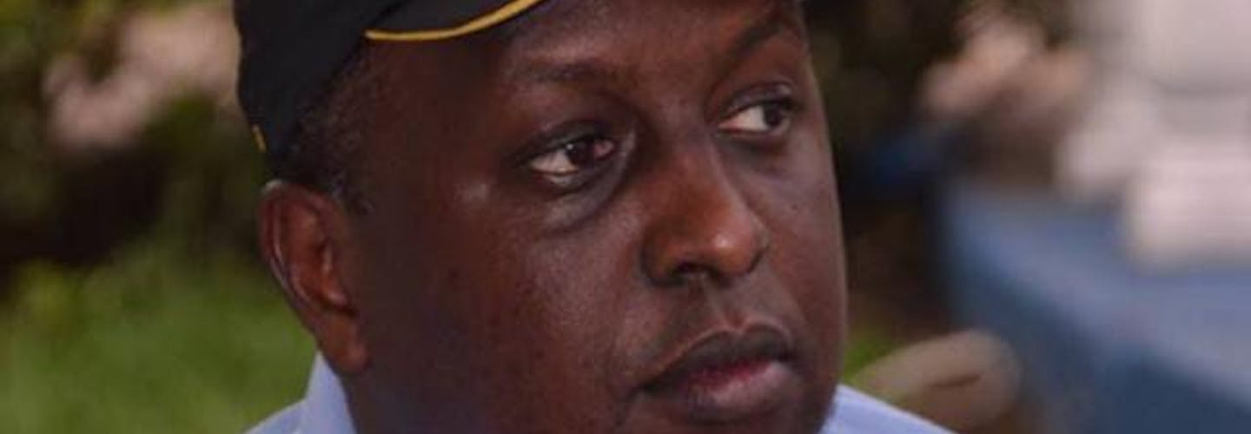

Christophe Sahabo, arts en directeur van een ziekenhuis in Burundi, werd in april 2022 gearresteerd vanwege een conflict over het management van het ziekenhuis. Tijdens een hoorzitting afgelopen september moest Sahabo overgeven en zakte in elkaar. Maar in plaats van hem naar een ziekenhuis te brengen, stuurden de autoriteiten Sahabo terug naar de gevangenis. Daar weigeren ze hem de medische zorg die hij dringend nodig heeft.
Wat kun jij voor Christophe Sahabo doen?
Schrijf vóór 1 januari 2025 naar de minister van Justitie van Burundi. Roep haar op om Christophe Sahabo de medische zorg te geven die hij nodig heeft.
Geen eerlijk proces
Sahabo wordt onder meer beschuldigd van fraude en witwassen. De beschuldigingen zijn tot nu toe niet bewezen en zijn recht op een eerlijk proces wordt op diverse manieren geschonden. Zo zat hij maandenlang vast zonder contact met de buitenwereld en werd zijn advocaat gearresteerd en geïntimideerd.

Schrijfactie: China,
laat filmmaker Pinlin onmiddellijk vrij!

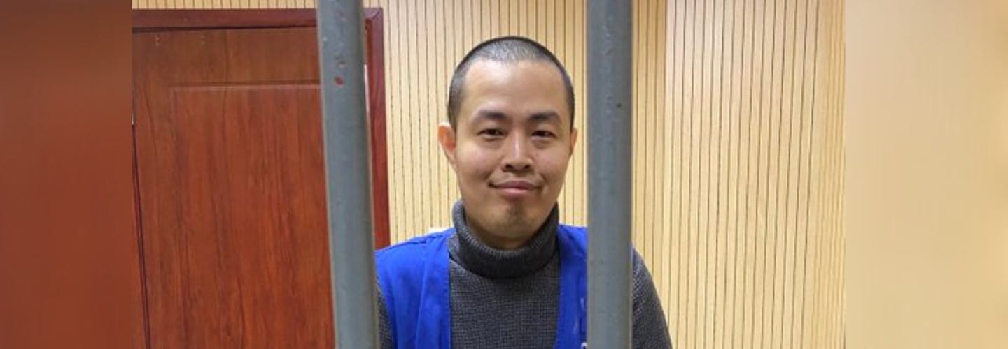

De Chinese filmmaker Chen Pinlin maakte een documentaire over de vreedzame protesten tegen de vergaande coronaregels en censuur in China. Hij zette de documentaire een jaar na de protesten, in november 2023, online. Hij werd meteen opgepakt. Pinlin riskeert nu vijf jaar gevangenisstraf vanwege zijn kritische documentaire. De autoriteiten klagen hem aan voor ‘het uitlokken van ruzies en problemen’. Zijn rechtszaak is uitgesteld tot maart volgend jaar.
Wat kun jij doen?
Schrijf vóór 1 januari 2025 naar de hoofdaanklager in China. Roep hem op om Chen Pinlin onmiddellijk vrij te laten.
Slechte gevangenisomstandigheden
Pinlin wordt in de gevangenis slecht behandeld. De cel waar hij in zit is zo overvol dat hij gedwongen op zijn zij moet slapen. Ook mag hij slechts één uur per maand naar buiten.

Mme Domine Banyankimbona
Ministre de la Justice
BP 1880
Bujumbura,
Burundi

E-mails: minjustice.burundi@gmail.com
infos@burundi.justice.gov.bi

Veldhoven, November 2024

Dear Minister,

I am alarmed by the poor state of health of Dr Christophe Sahabo, who has been detained since 1 April 2022. His condition is potentially life-threatening and he needs urgent medical attention.

The authorities’ deliberate denial of health care, causing severe pain and suffering, amounts to torture and other ill-treatment under international law. Under Burundian law (Article 33 of the 2017 law on the penitentiary system), detainees who are unwell have the right to be transferred to a medical institution for specialized care that is not available at the prison on the recommendation of the prison doctor.

In light of the above, I urge you to ensure that Dr Christophe Sahabo immediately receives appropriate medical attention and has unfettered access to his family and lawyers.
Thank you for your attention to this urgent matter. I am looking forward to your reply.

Yours sincerely,
Embassy of the Republic of Burundi,
Mr. Stany Muhizi
Carnegielaan 4-14
2517 KH Den Haag

E-mail: hburundiembassy@gmail.com

This is a copy of the letter sent to: Ministre de la Justice, Mme Domine Banyankimbona

Veldhoven, November 2024

Dear Minister,

I am alarmed by the poor state of health of Dr Christophe Sahabo, who has been detained since 1 April 2022. His condition is potentially life-threatening and he needs urgent medical attention.

The authorities’ deliberate denial of health care, causing severe pain and suffering, amounts to torture and other ill-treatment under international law. Under Burundian law (Article 33 of the 2017 law on the penitentiary system), detainees who are unwell have the right to be transferred to a medical institution for specialized care that is not available at the prison on the recommendation of the prison doctor.

In light of the above, I urge you to ensure that Dr Christophe Sahabo immediately receives appropriate medical attention and has unfettered access to his family and lawyers.
Thank you for your attention to this urgent matter. I am looking forward to your reply.

Yours sincerely,

Chief Procurator Chen Yong
Shanghai People's Procuratorate
75 Jian'guo West Rd, Shanghai, 200020
People’s Republic of China

Veldhoven, November 2024

Dear Chief Procurator Chen,
I am writing to express my grave concern for Chen Pinlin’s (陈品霖) well-being. He was arrested on 5 January 2024. In November 2023, Pinlin had released a documentary (乌鲁木齐中路) about the peaceful protests against the lockdowns under China’s zero-COVID policy and the harsh environment of censorship and surveillance. On 3 April 2024, he was brought before the Shanghai Baoshan District Court, and charged with 'picking quarrels and provoking troubles'. He is currently being held in pre-trial detention at the Baoshan Detention Center in Shanghai. While detained, Chen is subjected to poor treatment, including extremely overcrowded sleeping conditions and only being allowed one hour of outdoor activity per month. The inhumane conditions violate both the Prison Regulations and the Implementing Measures of the Prison Regulations.
Chen Pinlin is being detained solely for the peaceful exercise of his right to freedom of expression. Therefore, I urge you to release him immediately and unconditionally. Pending his release, please ensure he is not subjected to torture and other ill-treatment.
Thank you for your attention to this urgent matter.
Yours sincerely,

Embassy of the People's Republic of China
H. E. Ambassador Tan Jian
Willem Lodewijklaan 10
2517 JT Den Haag

E-mail: chinaemb_nl@mfa.gov.cn

This is a copy of the letter sent to:
Chief Procurator Chen Yong, Shanghai People's Procuratorate

Veldhoven, November 2024

Dear Chief Procurator Chen,
I am writing to express my grave concern for Chen Pinlin’s (陈品霖) well-being. He was arrested on 5 January 2024. In November 2023, Pinlin had released a documentary (乌鲁木齐中路) about the peaceful protests against the lockdowns under China’s zero-COVID policy and the harsh environment of censorship and surveillance. On 3 April 2024, he was brought before the Shanghai Baoshan District Court, and charged with 'picking quarrels and provoking troubles'. He is currently being held in pre-trial detention at the Baoshan Detention Center in Shanghai. While detained, Chen is subjected to poor treatment, including extremely overcrowded sleeping conditions and only being allowed one hour of outdoor activity per month. The inhumane conditions violate both the Prison Regulations and the Implementing Measures of the Prison Regulations.
Chen Pinlin is being detained solely for the peaceful exercise of his right to freedom of expression. Therefore, I urge you to release him immediately and unconditionally. Pending his release, please ensure he is not subjected to torture and other ill-treatment.
Thank you for your attention to this urgent matter.
Yours sincerely,

