Schrijfactie Jordanië:
wiskundeleraar krijgt 5 jaar cel voor kritiek op de koning

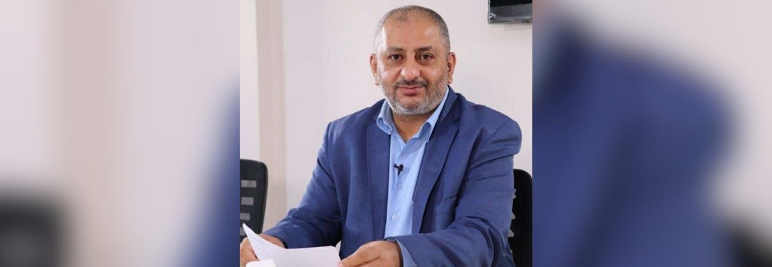

De Jordaanse wiskundeleraar en activist Ayman Sanduka postte in december 2023 een brief aan de koning op Facebook. Daarin uitte hij kritiek op de diplomatieke relaties van zijn land met Israël. Sanduka maakte alleen maar gebruik van zijn recht op vrijheid van meningsuiting. Toch werd hij tot 5 jaar gevangenisstraf veroordeeld.

Wat kun jij voor Ayman Sanduka doen?

Schrijf vóór 1 juni 2025 een brief aan de koning van Jordanië. Roep hem op om Ayman Sanduka onmiddellijk vrij te laten.

Kritiek wordt gesmoord
Sinds Israël in oktober 2023 Gaza binnenviel, gebruiken de Jordaanse autoriteiten allerlei vage wetten om journalisten, activisten en anderen die kritiek hebben op het Israël-beleid van de regering de mond te snoeren.

Schrijfactie Colombia:
activisten met de dood bedreigd

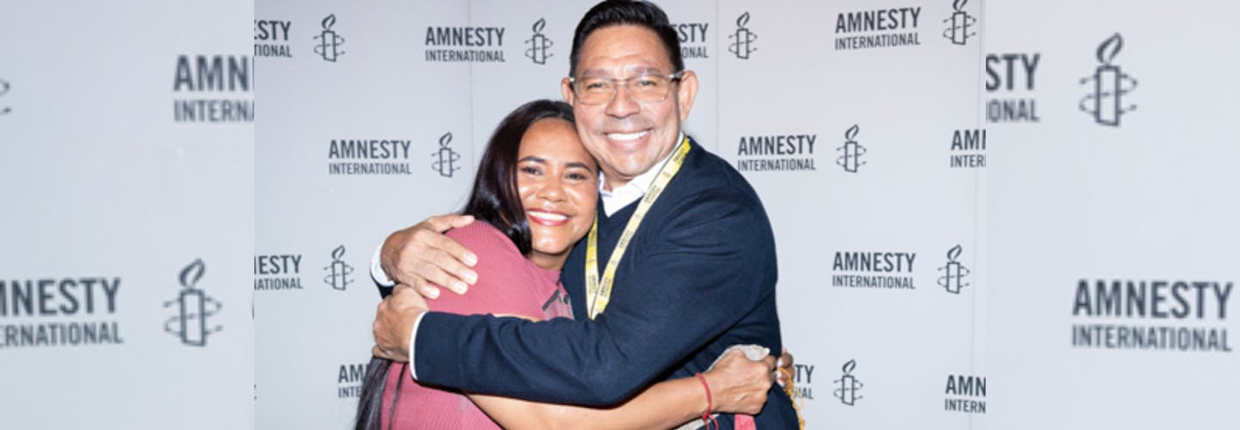

Activisten van de organisaties CREDHOS en FEDEPESAN zetten zich al jaren in voor de rechten van mensen in het noorden van Colombia. Ze doen dit met gevaar voor hun eigen leven. Ze worden voortdurend bedreigd en geïntimideerd door gewapende groepen en drugsbendes. Afgelopen januari kwam naar buiten dat er zelfs een plan lag om Iván Madero Vergel (foto rechts), de voorzitter van CREDHOS, te vermoorden. De Colombiaanse autoriteiten doen te weinig om dit geweld te stoppen.

Wat kun jij doen?

Schrijf vóór 1 juni 2025 een brief aan de minister van Binnenlandse Zaken van Colombia. Roep hem op om mensenrechtenorganisaties als CREDHOS en FEDEPESAN te beschermen tegen geweld.

Natuurlijke rijkdommen
In de regio Magdalena Medio in het noorden van Colombia vechten het Colombiaanse leger en minstens vier gewapende groeperingen om de natuurlijke rijkdommen van het gebied, zoals olie en water. Het geweld tegen mensenrechtenverdedigers, waaronder vele moorden, begon al minstens 40 jaar geleden.

His Majesty King Abdullah II ibn Al Hussein
Royal Hashemite Court
Amman
Jordan

Veldhoven, April 2025

Your Majesty,

I am distressed to learn that the State Security Court in Jordan has convicted political activist and mathematics professor, Ayman Sanduka, of “incitement to oppose the political regime” solely for exercising his right to freedom of expression on social media.

On 21 December 2023, the State Security Court prosecutor summoned and detained Ayman Sanduka in relation to a letter he posted on Facebook in October 2023 addressed to Your Majesty, in which he criticized Jordan’s diplomatic relations with Israel. On 7 January 2025, the State Security Court convicted Ayman Sanduka of "incitement to oppose the political regime”, under article 149 of the Penal Code and article 15 of the Cybercrimes Law and sentenced him to five years in prison.

I urge you to ensure that Ayman Sanduka is immediately and unconditionally released as he has been convicted solely for peacefully exercising his right to freedom of expression. Pending his release, I urge you to ensure that he is protected from torture and other cruel, inhuman or degrading treatment or punishment and has access to adequate medical care on request or as necessary.

Yours sincerely,

Embassy of the Hashemite Kingdom of Jordan
H.E. Mr. Daifallah Ali Daifallah Alfayez
Badhuisweg 79
2587 CD Den Haag

E-mail: thehague@fm.gov.jo

This is a copy of the letter sent to His Majesty King Abdullah II ibn Al Hussein

Veldhoven, April 2025

Your Majesty,

I am distressed to learn that the State Security Court in Jordan has convicted political activist and mathematics professor, Ayman Sanduka, of “incitement to oppose the political regime” solely for exercising his right to freedom of expression on social media.

On 21 December 2023, the State Security Court prosecutor summoned and detained Ayman Sanduka in relation to a letter he posted on Facebook in October 2023 addressed to Your Majesty, in which he criticized Jordan’s diplomatic relations with Israel. On 7 January 2025, the State Security Court convicted Ayman Sanduka of "incitement to oppose the political regime”, under article 149 of the Penal Code and article 15 of the Cybercrimes Law and sentenced him to five years in prison.

I urge you to ensure that Ayman Sanduka is immediately and unconditionally released as he has been convicted solely for peacefully exercising his right to freedom of expression. Pending his release, I urge you to ensure that he is protected from torture and other cruel, inhuman or degrading treatment or punishment and has access to adequate medical care on request or as necessary.

Yours sincerely,

Juan Fernando Cristo
Minister of Interior
Ministry of Interior of the Republic of Colombia
Carrera 8 No. 7 - 83
Bogotá DC,
Colombia

E-mail: servicioalciudadano@mininterior.gov.co

Veldhoven, April 2025

Dear Minister of Interior,

I am writing to express my deep concern with risk faced to the life, the safety and the security of the members of civil society organisations and communities at the Magdalena Medio region of Colombia. I am particularly concerned about the situation of the Corporación Regional para la Defensa de los Derechos Humanos – CREDHOS, and the Federación de Pescadores Artesanales Ambientalistas y Turísticos del Departamento de Santander – FEDEPESAN, located in Barrancabermeja. Their members continue to be attacked for defending the rights of the communities of Magdalena Medio, and the state's response remains insufficient.

I therefore urge you and other authorities to protect human rights defenders trough mechanisms of prevention and collective protection, and to guarantee the safety of organisations such as CREDHOS and FEDEPESAN.

Thank you for your attention to this urgent matter.

Yours sincerely,
Embassy of the Republic of Colombia
H. E. Mrs. Carolina Olarte Bácares
Groot Hertoginnelaan 14
2517 EG Den Haag

E-mail: epaisesbajos@cancilleria.gov.co

This is a copy of the letter sent to Juan Fernando Cristo Minister of Interior

Veldhoven, April 2025

Dear Minister of Interior,

I am writing to express my deep concern with risk faced to the life, the safety and the security of the members of civil society organisations and communities at the Magdalena Medio region of Colombia. I am particularly concerned about the situation of the Corporación Regional para la Defensa de los Derechos Humanos – CREDHOS, and the Federación de Pescadores Artesanales Ambientalistas y Turísticos del Departamento de Santander – FEDEPESAN, located in Barrancabermeja. Their members continue to be attacked for defending the rights of the communities of Magdalena Medio, and the state's response remains insufficient.

I therefore urge you and other authorities to protect human rights defenders trough mechanisms of prevention and collective protection, and to guarantee the safety of organisations such as CREDHOS and FEDEPESAN.

Thank you for your attention to this urgent matter.

Yours sincerely,

