Schrijfactie:
opnieuw celstraf voor Chinese journalist

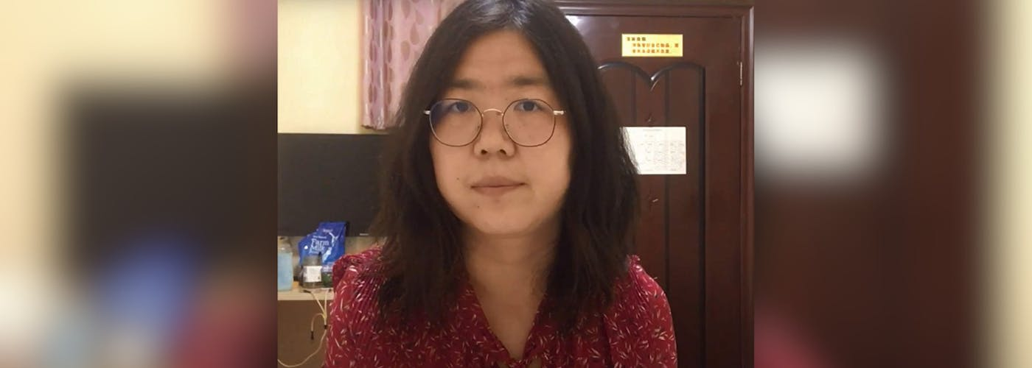

De Chinese journalist Zhang Zhan kreeg op 19 september 2025 opnieuw vier jaar gevangenisstraf voor “ruzie zoeken en problemen veroorzaken”. Toen ze in beroep ging, mocht ze haar familie en advocaat niet zien. Een tijdje wist niemand waar ze was. In november hoorde haar familie dat ze in de Shanghai vrouwengevangenis zit. Ze mogen haar nog steeds niet bezoeken en maken zich zorgen om haar gezondheid.

Wat kun jij voor Zhang Zhan doen?

Schrijf vóór 1 maart 2026 een brief aan de Chinese autoriteiten. Vraag hen om Zhang Zhan onmiddellijk vrij te laten en bezoek toe te staan.

Vast vanwege journalistieke werk
Zhang Zhan werd eerder veroordeeld omdat ze schreef over de uitbraak van corona in Wuhan. Ze liet op sociale media zien hoe verslaggevers werden opgepakt en families van patiënten geïntimideerd. Na vier jaar gevangenisstraf was ze nog maar kort vrij toen ze eind augustus 2024 opnieuw werd opgepakt.

Schrijfactie Bangladesh:
59 leden Bawm-minderheid vast zonder proces

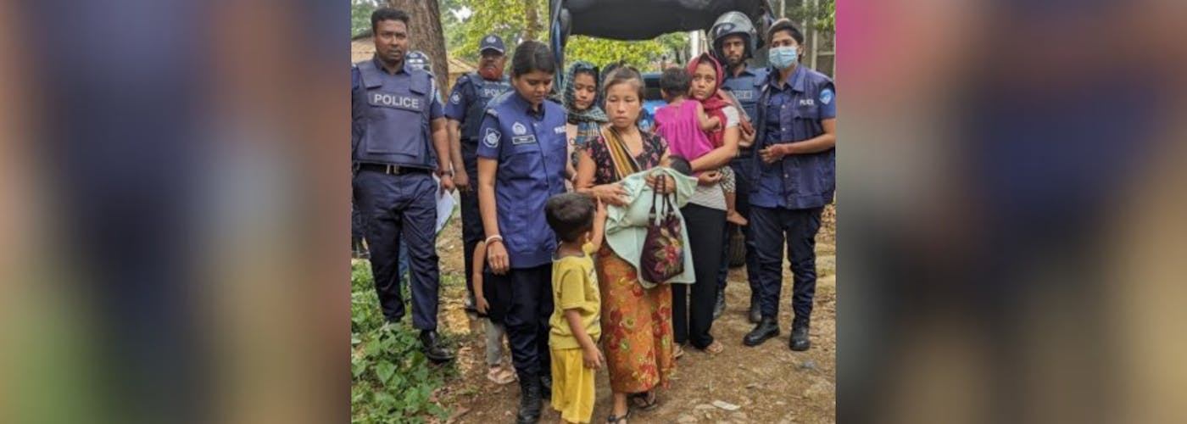

In Bangladesh zitten 59 Bawm-mensen, waaronder drie kinderen, nog steeds vast zonder proces. Volgens de autoriteiten zijn het ‘terroristen’. Ze zouden een groep steunen die in 2024 banken heeft beroofd. Van de 142 mensen die toen zijn opgepakt, zijn er drie in de gevangenis overleden door slechte medische zorg. 80 mensen zijn vrij op borgtocht.

Wat kun jij doen?

Schrijf vóór 1 maart 2026 een brief aan de autoriteiten in Bangladesh. Vraag hen deze mensen aan te klagen of vrij te laten.

Onderdrukte groep
De Bawm-gemeenschap is een van de kleinste inheemse groepen in het zuiden van Bangladesh. Ze lopen groot risico op collectieve bestraffing door de autoriteiten. Het leger zegt dat ze banden hebben met een gewapende oppositiegroep. Ongeveer 11.000 Bawm-mensen leven nu in angst voor arrestaties, honger en zonder toegang tot onderwijs of werk. In sommige dorpen heeft het leger kampen opgezet. Veel mensen zijn de jungle in gevlucht of proberen het land te verlaten.

Chief Adviser Muhammad Yunus
Government of the People’s Republic of Bangladesh
Old Sangsad Bhaban Tejgaon
Dhaka-1215
Bangladesh

E-mail: psecy@cao.gov.bd

Veldhoven, januari ’26

Dear Excellency,

Since April 2024, 142 Indigenous Bawm people, including three children, were arrested in the Chittagong Hill Tracts as part of an ongoing military operation. Eighteen months later, 59 remain jailed without trial. Three have died in custody amid poor healthcare.

Authorities accuse them of links to an armed group without evidence of individual responsibility, raising concerns of racial discrimination. Most of the 11,000 Bawm people live in fear of arrest, lack of education and employment.

I urge you to charge the detainees with a recognizable offence or release them, ensure legal aid, healthcare, and family visits, and end the crackdown on the Bawm community. In addition, I call on you to fully implement the Chittagong Hill Tracts Peace Accord.

Yours sincerely,

Embassy of Bangladesh
H.E. Mr. Tareque Muhammad
Stadhouderslaan 7
2517 HV Den Haag

E-mail: mission.hague@mofa.gov.bd

This is a copy of the letter sent to: Chief Adviser Muhammad Yunus

Veldhoven, januari ’26

Dear Excellency,

Since April 2024, 142 Indigenous Bawm people, including three children, were arrested in the Chittagong Hill Tracts as part of an ongoing military operation. Eighteen months later, 59 remain jailed without trial. Three have died in custody amid poor healthcare.

Authorities accuse them of links to an armed group without evidence of individual responsibility, raising concerns of racial discrimination. Most of the 11,000 Bawm people live in fear of arrest, lack of education and employment.

I urge you to charge the detainees with a recognizable offence or release them, ensure legal aid, healthcare, and family visits, and end the crackdown on the Bawm community. In addition, I call on you to fully implement the Chittagong Hill Tracts Peace Accord.

Yours sincerely,

Warden Chen Jianhua
Shanghai Women’s Prison
No. 1601 Zhangjing Road, Sijing Town
Songjiang District
Shanghai 201601
People’s Republic of China

Veldhoven, januari ’26

Dear Warden Chen,

I am deeply concerned about journalist and human rights defender Zhang Zhan (张展). On 19 September 2025, she was sentenced to four more years in prison for “picking quarrels and provoking trouble”, the same baseless charge for which she was previously imprisoned.

Since her appeal in September, her family and lawyer have been denied visits. For days, her whereabouts were unknown until 18 November, when it was confirmed she is held at Shanghai Women’s Prison. They still cannot visit her. Zhang’s health is a serious concern and her current condition is unknown.

I urge you to release Zhang Zhan immediately and quash her convictions. Pending release, allow regular, unrestricted visits by family and lawyers, ensure adequate medical care, and protect her from torture or ill-treatment.

Yours sincerely,

Embassy of the People's Republic of China
H. E. Ambassador TAN Jian
Willem Lodewijklaan 10
2517 JT Den Haag

E-mail: chinaemb_nl@mfa.gov.cn

This is a copy of the letter sent to:
Warden Chen Jianhua
Shanghai Women’s Prison
No. 1601 Zhangjing Road, Sijing Town
Songjiang District
Shanghai 201601

Veldhoven, januari ’26

Dear Warden Chen,

I am deeply concerned about journalist and human rights defender Zhang Zhan (张展). On 19 September 2025, she was sentenced to four more years in prison for “picking quarrels and provoking trouble”, the same baseless charge for which she was previously imprisoned.

Since her appeal in September, her family and lawyer have been denied visits. For days, her whereabouts were unknown until 18 November, when it was confirmed she is held at Shanghai Women’s Prison. They still cannot visit her. Zhang’s health is a serious concern and her current condition is unknown.

I urge you to release Zhang Zhan immediately and quash her convictions. Pending release, allow regular, unrestricted visits by family and lawyers, ensure adequate medical care, and protect her from torture or ill-treatment.

Yours sincerely,

