Schrijfactie India: laat activisten vrij

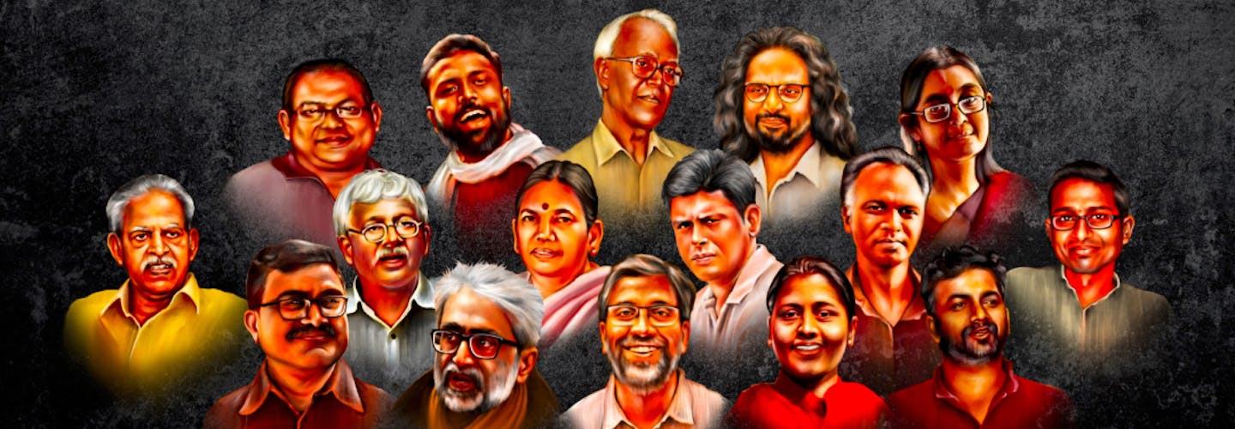

Sinds 2018 zijn er in India zestien bekende mensenrechtenactivisten opgepakt op basis van valse aanklachten. Een van hen, Fr. Stan Swamy (foto middenboven), overleed in de gevangenis doordat hij geen medische hulp kreeg. Een aantal personen is vrijgelaten, maar elf van hen zitten nog vast.

Wat kun jij doen?

Schrijf vóór 1 maart 2023 naar de minister van Binnenlandse Zaken van India. Roep hem op de 11 activisten die nog vastzitten onmiddellijk vrij te laten.

Nationale helden
De groep activisten wordt ook wel de BK16 genoemd. Deze bestaat uit dichters, advocaten, journalisten, professoren en een priester. Stuk voor stuk strijden ze voor de rechten van onderdrukte gemeenschappen in India, onder wie de Dalits en de Adivasis. Ze werden opgepakt omdat ze betrokken zouden zijn bij rellen die uitbraken in Bhima Koregaon begin 2018.

Schrijfactie Bahrein: laat Abdulhadi al-Khawaja vrij

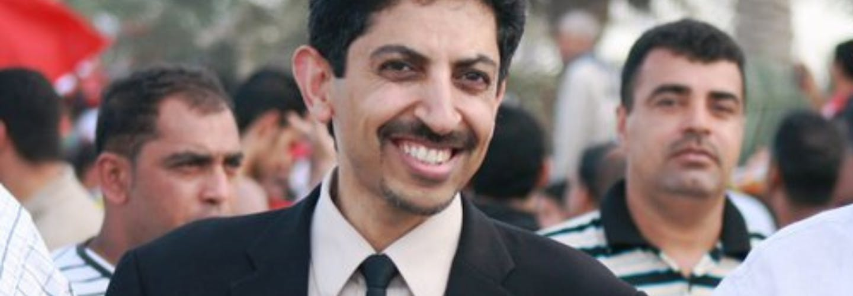
De 61-jarige Abdulhadi al-Khawaja is een zeer prominente mensenrechtenactivist uit Bahrein. Voor zijn activisme kreeg hij na een oneerlijk proces een levenslange gevangenisstraf. Hij zit al 11 jaar vast. Het gevangenispersoneel blijft manieren vinden om hem extra te straffen. Op 28 november 2022 kreeg Al-Khawaja twee boetes.

Wat kun jij doen?

Schrijf vóór 1 maart 2023 naar de autoriteiten van Bahrein. Roep hen op om Adbulhadi al-Khawaja onmiddellijk vrij te laten.

Boetes
De eerste boete kreeg Al-Khawaja omdat hij een stoel kapotmaakte en een gevangenismedewerker beledigd zou hebben, nadat deze hem telefoontjes met zijn dochters verbood. De tweede boete, ook voor het beledigen van een gevangenismedewerker, had te maken met zijn activisme.

Mr. Amit Shah, Union Home Minister of India
Ministry of Home Affairs
North Block
New Delhi - 110001

E-mail: jscpg-mha@nic.in / amitshah.mp@sansad.nic.in

Veldhoven, Januari 2023

Dear Minister Amit Shah,

Between 2018 and 2021, the Pune Police and National Investigation Agency arrested 16 human rights defenders for their involvement in the 2018 Bhima Koregaon riots. They were charged under various provisions of the draconian Unlawful Activities (Prevention) Act and the Indian Penal Code. The arrests appear to be politically motivated and relate to a massive crackdown on human rights defenders.

Fr. Stan Swamy, one of the 16 activists, died in detention on 5 July 2021. Since his arrest, his mental and physical health drastically deteriorated, and he was denied timely and effective medical treatment by the authorities. Sudha Bhardwaj, Varavara Rao and Anand Teltumbde were granted bail. Gautam Navlakha was shifted to house arrest. The other 11 activists continue to languish in jail without a trial.

I call for all charges against the 16 activists to be dropped, and for the immediate release of the 11 that remain in detention. Pending their release, the activists should be granted prompt, regular and unrestricted access to medical care and other basic necessities.

Yours sincerely,

Embassy of India
H. E. Mrs. Reenat Sandhu, Ambassador
Buitenrustweg 2
2517 KD Den Haag

E-mail: amb.thehague@mea.gov.in

This is a copy of the letter sent to: Mr. Amit Shah, Union Home Minister of India

Veldhoven, Januari 2023

Dear Minister Amit Shah,

Between 2018 and 2021, the Pune Police and National Investigation Agency arrested 16 human rights defenders for their involvement in the 2018 Bhima Koregaon riots. They were charged under various provisions of the draconian Unlawful Activities (Prevention) Act and the Indian Penal Code. The arrests appear to be politically motivated and relate to a massive crackdown on human rights defenders.

Fr. Stan Swamy, one of the 16 activists, died in detention on 5 July 2021. Since his arrest, his mental and physical health drastically deteriorated, and he was denied timely and effective medical treatment by the authorities. Sudha Bhardwaj, Varavara Rao and Anand Teltumbde were granted bail. Gautam Navlakha was shifted to house arrest. The other 11 activists continue to languish in jail without a trial.

I call for all charges against the 16 activists to be dropped, and for the immediate release of the 11 that remain in detention. Pending their release, the activists should be granted prompt, regular and unrestricted access to medical care and other basic necessities.

Yours sincerely,

Sheikh Salman bin Hamad
Crown Prince and Prime Minister
Court of the Crown Prince
P.O Box 29091, Riffa
Bahrain

E-mail (via contact form): http://www.crownprince.bh/en/contact

Veldhoven, Januari 2023

Your Highness,

Bahraini-Danish human rights defender and prisoner of conscience Abdulhadi al-Khawaja has been convicted and fined in two separate cases on 28 November 2022 by the Second Lower Criminal Court. He was convicted for breaking a chair and insulting a public servant in November 2021 while in Jaw prison after he was denied phone calls to his daughters. In a second case, Al-Khawaja was convicted of insulting a public servant in relation to an incident on 30 March 2022 when he protested against the normalization deal with Israel (Abraham Accords) and had an altercation with a prison officer. He was denied his right to be represented by a lawyer of his choosing and to be tried in his presence in both cases.

Al-Khawaja has so far spent more than 11 years of an unjust life sentence in Jaw prison for leading peaceful protests during the 2011 popular uprising in Bahrain. I therefore call upon your Highness to ensure that he is immediately and unconditionally released, that his convictions and sentences are quashed and any new charges brought against him are dropped.

Yours sincerely,

H.E. Mr. Abdulla bin Faisal bin Jabur Al Doseri
Embassy of the Kingdom of Bahrain
102 Avenue Franklin Roosevelt
1050 Brussel,
België

E-mail: Brussels.mission@mofa.gov.bh

This is a copy of the letter sent to: Sheikh Salman bin Hamad

Veldhoven, Januari 2023

Your Highness,

Bahraini-Danish human rights defender and prisoner of conscience Abdulhadi al-Khawaja has been convicted and fined in two separate cases on 28 November 2022 by the Second Lower Criminal Court. He was convicted for breaking a chair and insulting a public servant in November 2021 while in Jaw prison after he was denied phone calls to his daughters. In a second case, Al-Khawaja was convicted of insulting a public servant in relation to an incident on 30 March 2022 when he protested against the normalization deal with Israel (Abraham Accords) and had an altercation with a prison officer. He was denied his right to be represented by a lawyer of his choosing and to be tried in his presence in both cases.

Al-Khawaja has so far spent more than 11 years of an unjust life sentence in Jaw prison for leading peaceful protests during the 2011 popular uprising in Bahrain. I therefore call upon your Highness to ensure that he is immediately and unconditionally released, that his convictions and sentences are quashed and any new charges brought against him are dropped.

Yours sincerely,

