Schrijfactie Mozambique:
zwaar verminkt bij politiegeweld

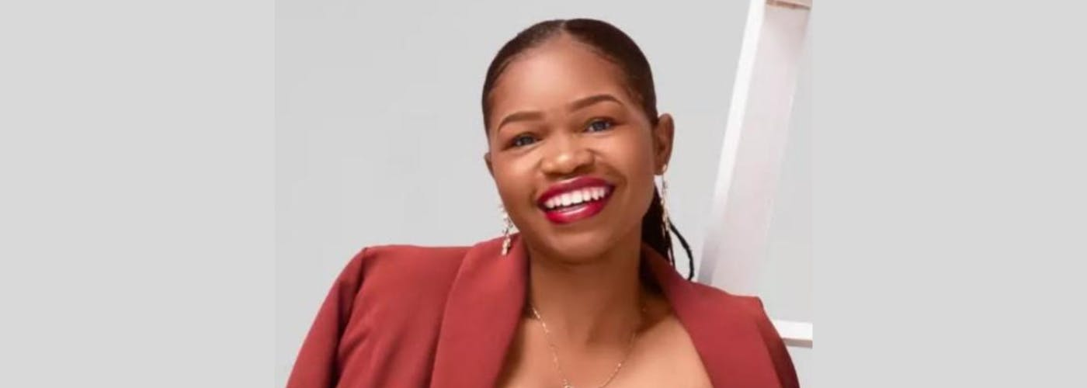

De 31-jarige kledingontwerper Alcina Nhaume was aan het werk in haar atelier in de Mozambikaanse hoofdstad Maputo, toen er rellen uitbraken. De politie greep in en er klonken schoten. Een daarvan ging dwars door een metalen rooster in de winkelruit en raakte haar in het gezicht.
Alcina is ernstig verminkt en zal waarschijnlijk nooit meer kunnen spreken. Ook eten zal grote moeite kosten. Momenteel krijgt ze sondevoeding.

Wat kun jij doen?
Schrijf vóór 1 juli 2025 een brief aan de openbaar aanklager in Mozambique. Roep hem op om een onderzoek in te stellen naar het schietincident waarbij Alcina Nhaume zwaar verminkt werd.

Loze belofte?
De autoriteiten hebben toegezegd de zaak te onderzoeken. Maar de vrees bestaat dat dit de zoveelste loze belofte van de overheid is en dat de daders nooit verantwoording zullen afleggen.

Schrijfactie Cuba:
7 jaar cel voor vreedzaam protest

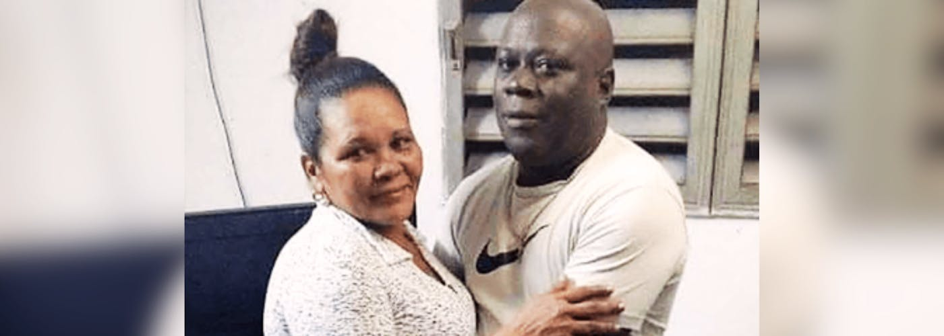

Loreto Hernández García is een Cubaanse activist en priester binnen de Afrikaanse Yoruba-religie. In juli 2021 werd hij samen met zijn vrouw Donaida opgepakt bij een vreedzame demonstratie tegen de regering. Ze uitten enkel hun mening en hebben niets misdaan. Toch werd Loreto veroordeeld tot 7 jaar gevangenisstraf vanwege het ‘verstoren van de openbare orde’ en ‘belediging’. Donaida kreeg 8 jaar opgelegd, maar kwam afgelopen januari vervroegd vrij.

Wat kun jij doen?

Schrijf vóór 1 juli 2025 een brief aan de president van Cuba. Roep hem op om Loreto Hernández García onmiddellijk vrij te laten.

Vervroegde vrijlating?
Loreto heeft diabetes en hoge bloeddruk, waarvoor hij in de gevangenis niet behandeld kan worden. Daarom hoopt hij dat hij op medische gronden vervroegd wordt vrijgelaten. Maar de autoriteiten hebben gezegd dat ze hem alleen laten gaan als zijn vrouw stopt met haar activisme.

Prosecutor General of the Republic
Américo Julião Letela
Av. Vladimir Lenine nr. 121
Maputo,
Mozambique

E-mail: denuncias@pgr.gov.mz

Veldhoven, May 2025

Dear Prosecutor General,

I am writing to express grave concern for designer Alcina Nhaume. On 5 March 2025, protests broke out in her neighbourhood Michafutene in Maputo, with residents barricading the road. According to witnesses the UIR-Rapid Intervention Unit had been deployed to disperse the protest, and soon after the police began chasing the protestors.

As Nhaume was about to grab her purse to go home, she heard several gunshots. One of the shots went through a metal barrier in the window of her shop and struck her in the face. Her face is severely disfigured. She is currently being fed through tubes, and according to her doctors she will never speak again, and will struggle to eat, unless she undergoes specialized surgery abroad. Even with such a surgery, it will take time for her to regain the ability to speak.

In light of the above, I call on you to promptly, independently, impartially and effectively conduct an investigation into Alcina Nhaume’s shooting, ensuring that the findings are made public, and the perpetrators are held accountable in fair trials.

Yours sincerely,

Embassy of the Republic of Mozambique
H. E. Excellency Ms. Ambassador Berta Celestino COSSA
Boulevard Saint Michel 97
1040 Brussels
Belgium

E-mail: info@embassyofmozambique.be

This is a copy of the letter sent to Prosecutor General of the Republic Américo Julião Letela

Veldhoven, May 2025

Dear Prosecutor General,

I am writing to express grave concern for designer Alcina Nhaume. On 5 March 2025, protests broke out in her neighbourhood Michafutene in Maputo, with residents barricading the road. According to witnesses the UIR-Rapid Intervention Unit had been deployed to disperse the protest, and soon after the police began chasing the protestors.

As Nhaume was about to grab her purse to go home, she heard several gunshots. One of the shots went through a metal barrier in the window of her shop and struck her in the face. Her face is severely disfigured. She is currently being fed through tubes, and according to her doctors she will never speak again, and will struggle to eat, unless she undergoes specialized surgery abroad. Even with such a surgery, it will take time for her to regain the ability to speak.

In light of the above, I call on you to promptly, independently, impartially and effectively conduct an investigation into Alcina Nhaume’s shooting, ensuring that the findings are made public, and the perpetrators are held accountable in fair trials.

Yours sincerely,

Presidente de Cuba
Miguel Mario Díaz-Canel Bermúdez
Hidalgo Esq. 6, Plaza de La Revolución
CP 10400, La Habana
Cuba

Veldhoven, May 2025

Your Excellency,

Loreto Hernández García is a black Cuban activist, priest, and vice president of the Asociación Yorubas Libres de Cuba, which practices the African Yoruba religion. He was arrested by police on July 15, 2021, after peacefully participating in an anti-government demonstration. In February 2022, a court in the city of Santa Clara sentenced him to seven years in prison for "disturbing public order" and "contempt”. Both charges are frequently used in Cuba to restrict the rights to freedom of expression and assembly. In the unfair trial, he, his wife, Donaida Pérez Paseiro, and 14 other demonstrators were found guilty.

According to his family, Loreto Hernández García has been held in solitary confinement several times since 2021, sometimes for more than two weeks. He suffers from diabetes, high blood pressure, and other health problems that cannot be treated in prison. Due to his poor health, he hopes for conditional release. However, authorities have told him that he will only be released if his wife, who was released from prison on January 15, 2025, ceases her activism.

In light of the above, I urge you to immediately and unconditionally release Loreto Hernández García, as he is unlawfully detained solely for exercising his human rights.

Yours sincerely,

Embassy of the Republic of Cuba
H.E. Ms. Eva Yelina Silva Walker
Koninginnegracht 37
2514 AD Den Haag

E-mail: embajada@nl.embacuba.cu

This is a copy of the letter sent to Presidente de Cuba Miguel Mario Díaz-Canel Bermúdez

Presidente de Cuba
Miguel Mario Díaz-Canel Bermúdez

Veldhoven, May 2025

Your Excellency,

Loreto Hernández García is a black Cuban activist, priest, and vice president of the Asociación Yorubas Libres de Cuba, which practices the African Yoruba religion. He was arrested by police on July 15, 2021, after peacefully participating in an anti-government demonstration. In February 2022, a court in the city of Santa Clara sentenced him to seven years in prison for "disturbing public order" and "contempt”. Both charges are frequently used in Cuba to restrict the rights to freedom of expression and assembly. In the unfair trial, he, his wife, Donaida Pérez Paseiro, and 14 other demonstrators were found guilty.

According to his family, Loreto Hernández García has been held in solitary confinement several times since 2021, sometimes for more than two weeks. He suffers from diabetes, high blood pressure, and other health problems that cannot be treated in prison. Due to his poor health, he hopes for conditional release. However, authorities have told him that he will only be released if his wife, who was released from prison on January 15, 2025, ceases her activism.

In light of the above, I urge you to immediately and unconditionally release Loreto Hernández García, as he is unlawfully detained solely for exercising his human rights.

Yours sincerely,

