Schrijfactie Equatoriaal-Guinee:

activist afgesneden van de buitenwereld

Afbeelding met Menselijk gezicht, persoon, kleding, person

Door AI gegenereerde inhoud is mogelijk onjuist.

Op 13 August 2024 werd Equatoriaal-Guinese mensenrechtenactivist Joaquín Elo Ayeto overgebracht naar een gevangenis voor politieke gevangenen. Sindsdien heeft niemand meer iets van hem vernomen. Ayeto werkt voor de mensenrechtenorganisatie Somos+, die volgens de autoriteiten niet geregistreerd is. Daarom wordt hij beschuldigd van illegale activiteiten. Een poging om hem het zwijgen op te leggen.

Bij zijn arrestatie leed Ayeto aan malaria en tyfus. Zijn familie maakt zich grote zorgen, maar krijgt geen informatie over zijn gezondheid.

Wat kun jij doen?

Schrijf vóór 1 december 2025 een brief aan de president van Equatoriaal-Guinee en vraag om de onmiddellijke vrijlating van Joaquín Elo Ayeto.

Verzonnen aanklacht

Ayeto werd op 1 augustus 2024 gearresteerd, kort nadat hij met de Franse ambassadeur sprak over mensenrechtenschendingen op het eiland Annobón als gevolg van de mijnbouw daar. Als lid van een oppositiepartij en mensenrechtenorganisatie wordt hij voortdurend lastiggevallen, mishandeld en vastgezet op basis van verzonnen aanklachten.

Schrijfactie Mexico:

directeur mensenrechtenorganisatie in Mexico bedreigd

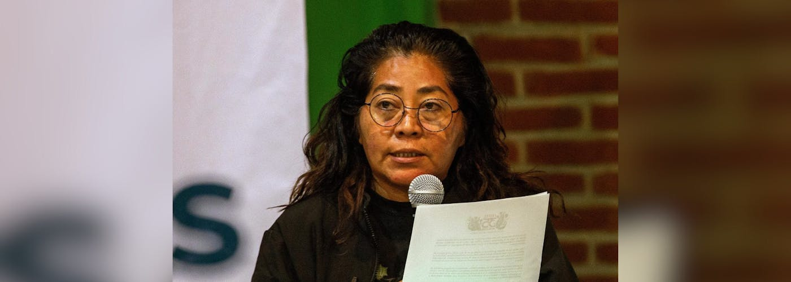

Dora Roblero is de directeur van Frayba, een mensenrechtenorganisatie in Chiapas, Mexico. Chiapas is een gevaarlijke plek. Sinds 2010 hebben Roblero en haar collega’s recht op bescherming van de overheid. Dat komt omdat hun werk gevaarlijk is. Op 22 juli kwam Roblero thuis. Ze zag dat haar voordeur kapot was en dat er was ingebroken. Ze vroeg meteen om hulp via een speciaal noodplan. Maar volgens haar was de reactie traag en onvoldoende.

Wat kun jij doen?

Schrijf vóór 1 december 2025 een brief aan de minister van Binnenlandse Zaken. Vraag haar om Dora Roblero en haar collega’s bij Frayba te beschermen.

Geen op zichzelf staande aanval

Frayba heeft in 11 maanden meer dan 51 problemen gemeld. Medewerkers worden lastiggevallen, bedreigd en gevolgd. Toch doet de Mexicaanse overheid nog te weinig. De aanvallen worden niet goed onderzocht en de mensen worden niet goed beschermd.

Teodoro Obiang Nguema Mbasogo

President of Equatorial Guinea

Palacio Presidencial de Guinea Ecuatorial

Avenida de Libertad,

Malabo,

Guinea Ecuatorial

Veldhoven, October 2025

Your Excellency,

I am deeply concerned about the arbitrary detention of human rights defender Joaquín Elo Ayeto, who is imprisoned solely for peacefully exercising his rights. Since his transfer to Oveng Azem prison on 13 August 2024, he has been held incommunicado. The denial of access of prisoners to their families and lawyers is a violation under international law.

His family reports he was suffering from typhoid and malaria at the time of arrest, and they have received no updates on his condition, adding to their distress.

I urge you to ensure the immediate release of Joaquín Elo Ayeto. Until then, he must be granted access to his family, legal counsel, and urgent medical care, in full compliance with international human rights standards.

Yours sincerely,

Mission of Equatorial Guinea to the European Union

Place Guy d'Arezzo 6

1180 Brussel

België

E-mail: guineaecuatorial.brux@skynet.be

**This is a copy of the letter sent to:**

Teodoro Obiang Nguema Mbasogo, President of Equatorial Guinea

Veldhoven, October 2025

Your Excellency,

I am deeply concerned about the arbitrary detention of human rights defender Joaquín Elo Ayeto, who is imprisoned solely for peacefully exercising his rights. Since his transfer to Oveng Azem prison on 13 August 2024, he has been held incommunicado. The denial of access of prisoners to their families and lawyers is a violation under international law.

His family reports he was suffering from typhoid and malaria at the time of arrest, and they have received no updates on his condition, adding to their distress.

I urge you to ensure the immediate release of Joaquín Elo Ayeto. Until then, he must be granted access to his family, legal counsel, and urgent medical care, in full compliance with international human rights standards.

Yours sincerely,

Rosa Icela Rodríguez Velázquez, Ministry of the Interior

Abraham González 48, Colonia Juárez

Alcaldía Cuauhtémoc, CP 06600

Mexico City,

Mexico

E-mail: secretario@segob.gob.mx

Veldhoven, October 2025

Dear Ministry of Interior,

I am writing to express my deep concern about the recent attack against Dora Roblero, director of the Fray Bartolomé de Las Casas Human Rights Center (CDH Frayba). On 22 July, her home was raided by unknown individuals. She immediately activated emergency measures through the Protection Mechanism for Human Rights Defenders. However, their response was slow and ineffective. This is not an isolated attack. The CDH Frayba has reported more than 51 incidents, including harassment, intimidation, and surveillance against its members over the past 11 months.

I urge the Mechanism for the Protection of Human Rights Defenders to implement all necessary measures to guarantee the safety of the members of CDH Frayba, in full compliance with the precautionary measures issued by the Inter-American Commission on Human Rights in 2010. In addition, I urge you to investigate these attacks and to bring those responsible to justice.

Thank you for your attention to this urgent matter.

Yours sincerely,

Embassy of Mexico in the Netherlands

H.E. Mrs. Carmen Moreno Toscano

Nassauplein 28

2585 EC, Den Haag

E-mail: embamexpba@sre.gob.mx

**This is a copy of the letter sent to:**

Rosa Icela Rodríguez Velázquez, Ministry of the Interior

Veldhoven, October 2025

Dear Ministry of Interior,

I am writing to express my deep concern about the recent attack against Dora Roblero, director of the Fray Bartolomé de Las Casas Human Rights Center (CDH Frayba). On 22 July, her home was raided by unknown individuals. She immediately activated emergency measures through the Protection Mechanism for Human Rights Defenders. However, their response was slow and ineffective. This is not an isolated attack. The CDH Frayba has reported more than 51 incidents, including harassment, intimidation, and surveillance against its members over the past 11 months.

I urge the Mechanism for the Protection of Human Rights Defenders to implement all necessary measures to guarantee the safety of the members of CDH Frayba, in full compliance with the precautionary measures issued by the Inter-American Commission on Human Rights in 2010. In addition, I urge you to investigate these attacks and to bring those responsible to justice.

Thank you for your attention to this urgent matter.

Yours sincerely,