Schrijfactie China:
waar is Gao Zhisheng?

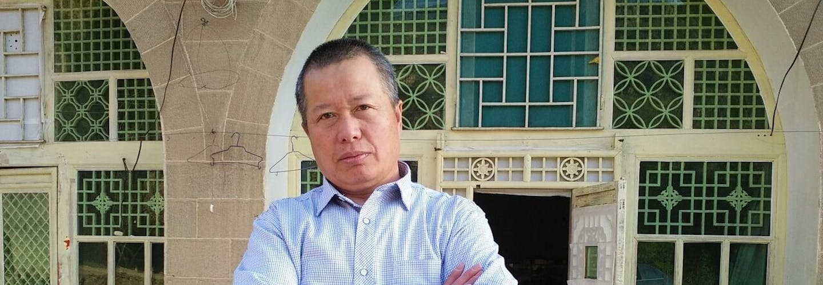

De Chinese advocaat Gao Zhisheng wordt al bijna 7 jaar in het geheim vastgehouden. Hij werd opgepakt nadat hij zijn memoires publiceerde. Daarin schreef hij over zijn ervaringen als gevangene en onder surveillance in China. Zijn exacte locatie en huidige toestand blijven onduidelijk. Zonder toegang tot een advocaat, en gezien zijn eerdere behandeling in de gevangenis, loopt hij groot risico op marteling.

Wat kun jij voor Gao Zhisheng doen?
Schrijf vóór 1 juni 2024 naar de minister van Openbare Veiligheid in China. Roep hem op om Gao Zhisheng onmiddellijk vrij te laten.

Eerder jarenlang vermist
Gao Zhisheng is een van de meest gerespecteerde mensenrechtenadvocaten in China. Hij verdedigde onder meer activisten en religieuze minderheden. De autoriteiten pakten hem in 2006 ook al op nadat hij een hongerstaking organiseerde om aandacht te vragen voor de vervolging van mensenrechtenactivisten in China. Gedurende het grootste deel van de volgende 10 jaar was Gao vermist, zat hij opgesloten of werd hij onder huisarrest geplaatst. Maar hij bleef zich uitspreken over mensenrechtenschendingen en zijn kritiek uiten op de Chinese Communistische Partij.

Schrijfactie:
Mexico, bescherm journalist Alberto Amaro

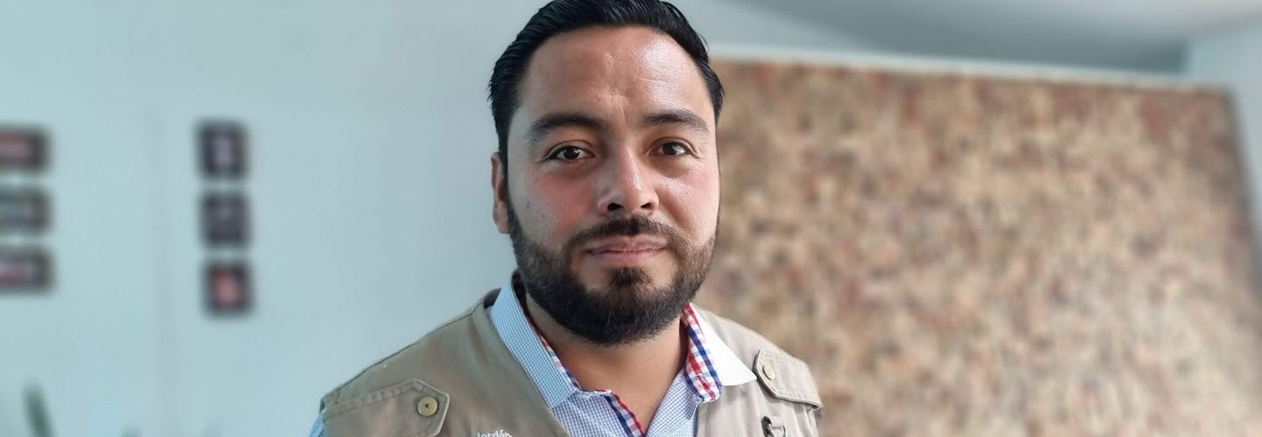

De 35-jarige Mexicaanse journalist Alberto Amaro doet zijn werk met gevaar voor eigen leven. Hij is al meerdere keren aangevallen. In januari nog probeerde iemand opzettelijk op hem in te rijden. Amaro ontsnapte ternauwernood. Hij heeft recht op goede bescherming van de Mexicaanse overheid.

Wat kun jij voor Alberto Amaro doen?

Schrijf vóór 1 mei 2024 naar de minister van Binnenlandse Zaken van Mexico. Roep haar op ervoor te zorgen dat Alberto Amaro zijn werk in veiligheid kan doen.

Overheid wil bescherming opheffen
Mexico is een van de meest gevaarlijke land ter wereld voor journalisten. Amaro is in elkaar geslagen, beschoten, en geïntimideerd door de politie en leden van een drugskartel. Sinds 2019 zorgt de overheid ervoor dat bodyguards Amaro beschermen. Maar vorig jaar besloot de overheid dat hij niet langer gevaar loopt. Ze wilden zijn bescherming beëindigen. De recente aanval op zijn leven laat zien dat die bescherming nog hard nodig is.

Minister of Public Security, Wang Xiaohong
14 Dongchanganjie, Dongchengqu
Beijing Shi 100741
People’s Republic of China

Veldhoven, April 2024

Dear Minister,

I wish to express my concern about human rights lawyer and former prisoner of conscience Gao Zhisheng. He has been missing from his home in Yulin City, Shaanxi, since 13 August 2017. A government official informed Zhisheng’s family in September 2017 that he had been taken to Beijing. His exact location, his condition as well as the grounds for his detention remain unclear. I am concerned that given his previous treatment in detention he is at grave risk of torture and other ill-treatment.

Therefore, I urge you to immediately disclose the whereabouts and the well-being of Gao and to release him unconditionally. Pending his release, please ensure that he is not subjected to torture or other ill-treatment, and that he has regular, unrestricted access to his family, lawyers of his choice, and medical care.

Thank you for your attention to this urgent matter. I am kindly awaiting your reply.

Yours sincerely,

Embassy of China
H.E. Ambassador TAN Jian
Willem Lodewijklaan 10
2517 JT Den Haag

This is a copy of the letter sent to: Minister of Public Security, Wang Xiaohong

Veldhoven, April 2024

Dear Minister,

I wish to express my concern about human rights lawyer and former prisoner of conscience Gao Zhisheng. He has been missing from his home in Yulin City, Shaanxi, since 13 August 2017. A government official informed Zhisheng’s family in September 2017 that he had been taken to Beijing. His exact location, his condition as well as the grounds for his detention remain unclear. I am concerned that given his previous treatment in detention he is at grave risk of torture and other ill-treatment.

Therefore, I urge you to immediately disclose the whereabouts and the well-being of Gao and to release him unconditionally. Pending his release, please ensure that he is not subjected to torture or other ill-treatment, and that he has regular, unrestricted access to his family, lawyers of his choice, and medical care.

Thank you for your attention to this urgent matter. I am kindly awaiting your reply.

Yours sincerely,

Minister Luisa María Alcalde Luján
Ministry of Interior (SEGOB)
Carretera Bucareli 99
Colonia Juárez, Cuauhtemoc
C.P. 06600, Mexico City, Mexico

E-mail: luisa.alcalde@segob.gob.mx

Veldhoven, April 2024

Dear Minister,

I’m writing to express my deep concern about the security situation of journalist Alberto Amaro Jordán, director of the Mexican media outlet La Prensa de Tlaxcala. Due to his work, Alberto has been the victim of several very serious attacks. In January 2024, he was chased by an unknown person in a vehicle who attempted to crash into his vehicle. Despite this, officials from Mexico’s Mechanism for the Protection of Human Rights Defenders and Journalists have questioned his claims and even attempted to withdraw Amaro’s protective measures.

I therefore urge you to immediately reassess Alberto Amaro’s security situation, in consultation with him, guarantee that his existing protective measures are not withdrawn and grant any additional measures that are needed to guarantee his safety, as well as ensuring that authorities investigate any attacks against him.

Yours sincerely

Ambassade van de Verenigde Mexicaanse Staten
H.E. Mrs. Carmen de la Soledad Moreno Toscano
Nassauplein 28
2585 EC Den Haag

E-mail: embamexpba@sre.gob.mx

This is a copy of the letter sent to: Minister Luisa María Alcalde Luján

Veldhoven, April 2024

Dear Minister,

I’m writing to express my deep concern about the security situation of journalist Alberto Amaro Jordán, director of the Mexican media outlet La Prensa de Tlaxcala. Due to his work, Alberto has been the victim of several very serious attacks. In January 2024, he was chased by an unknown person in a vehicle who attempted to crash into his vehicle. Despite this, officials from Mexico’s Mechanism for the Protection of Human Rights Defenders and Journalists have questioned his claims and even attempted to withdraw Amaro’s protective measures.

I therefore urge you to immediately reassess Alberto Amaro’s security situation, in consultation with him, guarantee that his existing protective measures are not withdrawn and grant any additional measures that are needed to guarantee his safety, as well as ensuring that authorities investigate any attacks against him.

Yours sincerely

